ECE 321L - Lab 5

October 16, 2012

Greg Iven

Mario Chaves

Contents

Abstract 3

Procedure 3

Hand Calculations 3

Nmos Circuit Measured Parameters 3

Nmos Parameters Compared 4

Code for Circuit 2 P-Spice 4

Circuit 2 Simulation Output 4

Results 6

Conclusion 6

Abstract  
 In this lab we constructed a circuit in Pspice, and verified hand calculations of Vds, Vgs, and Ids to the Pspice simulations’ for the circuit.

Procedure

* We first calculated Vds, Vgs, and Ids by hand
* Then we constructed the circuits using Pspice
* Then we verified the hand calculations using Pspice
* We compared the values to the measured values of the circuit.

## Hand Calculations

$Ids=(\frac{.001825*1}{2}*\left(3-Ids*535-1\right)Vds-{\frac{Vds}{2}}^{2})$

$$Ids=1.41mA$$

Not 9.89mA

$$Vds=\left(3-1.41ma*1615\right)=.722v$$

$$Vgs=\left(3-\left(1.41ma*535\right)\right)=2.245v$$

$$Vs=1.41ma*535=.754v$$

$$Vd=3-1.41ma*1.08=1.4772$$

$$Vg=3v$$

## Nmos Circuit Measured Parameters

|  |  |  |  |
| --- | --- | --- | --- |
|  | Resistance Measured | Current Measured | Voltage Measured |
| R2 | 6.18KΩ | 0.484mA | X |
| Rs | 535Ω | 1.37mA | X |
| Rd | 1.08kΩ | 1.37mA | X |
| Vg | X | X | 3V |
| Vs | X | X | 0.763V |
| Vd | X | X | 1.49V |
| Vds | X | X | 0.769V |
| Vgs | X | X | 2.25V |

## 

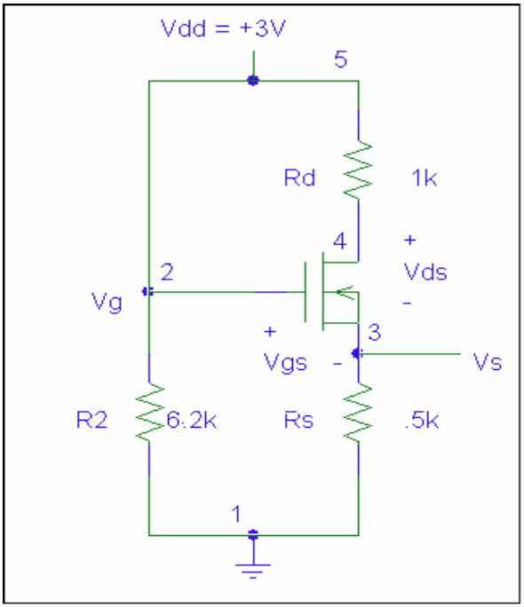

Figure Nmos Circuit with nodes labeled

## Code for Circuit 2 P-Spice

r2 1 5 6.18k

rd 4 5 1.08k

rs 1 3 535

vdd 5 0 dc 3

vss 1 0 dc 0

m1 4 5 3 3 ntype l=1.0u w=1.0u

.model ntype nmos level=2 vto=1 kp=.9125e-3

.op

.end

## Circuit 2 Simulation Output

**** 01/29/13 16:23:34 ****** PSpice 16.5.0 (April 2011) ****** ID# 0 ********

lab1

**** CIRCUIT DESCRIPTION

******************************************************************************

r2 1 5 6.18krd 4 5 1.08k

rs 1 3 535

vdd 5 0 dc 3

vss 1 0 dc 0

m1 4 5 3 3 ntype l=1.0u w=1.0u

.model ntype nmos level=2 vto=1 kp=.9125e-3

.op

.end

**** 01/29/13 16:08:23 ****** PSpice 16.5.0 (April 2011) ****** ID# 0 ********

r2 1 5 6.18k

**** MOSFET MODEL PARAMETERS

******************************************************************************

ntype

NMOS

LEVEL 2

L 100.000000E-06

W 100.000000E-06

VTO 1

KP 912.500000E-06

GAMMA 0

PHI .6

LAMBDA 0

IS 10.000000E-15

JS 0

PB .8

PBSW .8

CJ 0

CJSW 0

CGSO 0

CGDO 0

CGBO 0

TOX 100.000000E-09

XJ 0

UCRIT 10.000000E+03

DIOMOD 1

VFB 0

LETA 0

WETA 0

U0 0

TEMP 0

VDD 5

XPART 0

**** 01/29/13 16:08:23 ****** PSpice 16.5.0 (April 2011) ****** ID# 0 ********

r2 1 5 6.18k

**** SMALL SIGNAL BIAS SOLUTION TEMPERATURE = 27.000 DEG C

******************************************************************************

NODE VOLTAGE NODE VOLTAGE NODE VOLTAGE NODE VOLTAGE

( 1) 0.0000 ( 3) .5279 ( 4) 1.9343 ( 5) 3.0000

VOLTAGE SOURCE CURRENTS

NAME CURRENT

vdd -9.867E-04

vss 9.867E-04

TOTAL POWER DISSIPATION 2.96E-03 WATTS

**** 01/29/13 16:08:23 ****** PSpice 16.5.0 (April 2011) ****** ID# 0 ********

r2 1 5 6.18k

**** OPERATING POINT INFORMATION TEMPERATURE = 27.000 DEG C

******************************************************************************

**** MOSFETS

NAME m1

MODEL ntype

ID 9.87E-04

VGS 2.47E+00

VDS 1.41E+00

VBS 0.00E+00

VTH 1.00E+00

VDSAT 1.47E+00

Lin0/Sat1 -1.00E+00

if -1.00E+00

ir -1.00E+00

TAU -1.00E+00

GM 1.28E-03

GDS 5.99E-05

GMB 0.00E+00

CBD 0.00E+00

CBS 0.00E+00

CGSOV 0.00E+00

CGDOV 0.00E+00

CGBOV 0.00E+00

CGS 2.21E-16

CGD 2.82E-17

CGB 0.00E+00

JOB CONCLUDED

**** 01/29/13 16:08:23 ****** PSpice 16.5.0 (April 2011) ****** ID# 0 ********

r2 1 5 6.18k

**** JOB STATISTICS SUMMARY

******************************************************************************

Total job time (using Solver 1) = 0.00

# Results

## Nmos Parameters Compared

|  |  |  |  |
| --- | --- | --- | --- |
|  | Calculated Values | Measured Values | PSpice Values |
| Id | 1.41mA | 1.37mA | 0.987mA |
| Vg | 3V | 3V | 3V |
| Vs | 0.754V | 0.763V | .5279V |
| Vd | 1.4772V | 1.49V | 1.9343V |
| Vds | 0.722V | 0.769V | 1.41V |
| Vgs | 2.245V | 2.25V | 2.47V |

Conclusion  
 In performing this experiment we expanded our knowledge of Pspice, and how to construct circuits in it. Through our hand calculations we were able to learn more about the electrical characteristics of transistors. We learned a new way to verify our hand calculations, through using programs like Pspice.